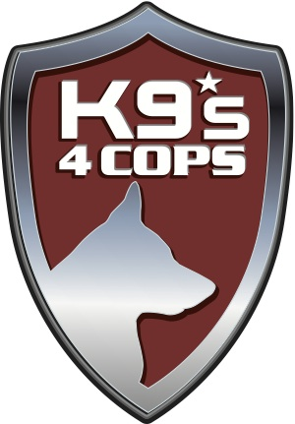
i would like to support K9s4COPs in the following manner:
O $50,000 Top Dog (Exclusive Sponsorship)
Two preferred tables for ten. Special acknowledgement during the evening. Corporate or Foundation logo featured on the event signage and on the K9s4COPs website. Corporate or Foundation logo in the program on the inside or back cover of the program. Private reception honoring Houston Interim Police Chief Martha Montalvo with all of your guests.
O $25,000 Leader of the Pack
Preferred table for ten. Special recognition during the event and on the K9s4COPs website. Corporate or Foundation recognition in a full page format in the program. Private reception honoring Houston Interim Police Chief Martha Montalvo with your guests.

UNDERWRITER RESPONSE FORM
I would like to support K9s4COPs

O $15,000 Alpha Dog
Special reserved table for ten. Special recognition during the event and on the K9s4COPs website. Corporate logo or Foundation logo featured on the K9s4COPs website. Corporate or Foundation recognition with a half page in the program. Private reception honoring Houston Interim Police Chief Martha Montalvo with eight of your guests.
O $10,000 K9 Swat
Special reserved table for ten. Special recognition during the event and on the K9s4COPs website. Corporate logo or Foundation logo featured on the K9s4COPs website. Corporate or Foundation recognition in the program. Private reception honoring Houston Interim Police Chief Martha Montalvo with six of your guests.
O $7,500 Woof Pack
Special reserved table for ten. Corporate logo or Foundation logo featured on the K9s4COPs website and recognition during the event. Corporate or Foundation recognition in the program. Private reception honoring Houston Interim Police Chief Martha Montalvo with four of your guests

O $5,000 K9s4KIDs
Special reserved table for ten. Corporate logo or Foundation logo featured on the K9s4COPs website and recognition during the event. Corporate or Foundation recognition in the program. Private reception honoring Houston Interim Police Chief Martha Montalvo with two of your guests.
O $2,500 Sheriff’s Badge
Table for ten. Name recognition on the K9s4COPs website and in the Unleashed program.
O $250 Friends of K9s4COPs
Reserved seating for an individual ticket
Deadline is October 17, 2016.
Payment
Enclosed is a check in the amount of $ made payable to K9s4COPs.
This Gift is in Honor of
Charge $ to my O MC O Visa O AMEX O Discover.
Credit Card # Expires
K9s4COPs, Inc.
5858 Westheimer
Suite 700
Houston, TX 77057

713.523.2677
Roseann@K9s4COPs.org

www.K9s4COPs.org

Find us on Facebook, Instagram and Twitter: @K9s4COPS
Print Name as it Appears on Card
Signature

Name/Company
Name as you would like it to appear in printed materials
Address, City, State, Zip

If you have any questions, please contact Roseann Rogers at Roseann@K9s4COPs.org.
K9s4COPs is a 501(c)(3) organization. For tax purposes, the estimated fair market value per ticket is $195.

